
DDoS Detection in Kubernetes using Machine and Deep Learning

Group Members
Asher Siddiqui 21K-3860
Rija Anwar 21K-3069
Mahnoor Amjad 21K-3884
Supervisor: Mr. Shoaib Raza

Supervisor Signature: _____________________
Abstract
In the recent years, cloud technology has advanced across all disciplines and used worldwide. Micro-service architecture, infamous for deploying services as per the user demands has also spread notoriously. Cloud is known for deploying on-demand services and micro-services are known for being the most scalable as the user traffic/demand grows. This is why these both go hand-in-hand because as the traffic grows new services can be deployed on demand. As with all technology, the responsibility of making cloud a secure environment to protect the users’ interests and data is a primary concern.

The buildout of cloud native applications and micro-service architectures across various systems and tech in the industry has brought about an intensity in the need for a set of effective mechanisms to deal with DoS (Denial of Service) and DDoS (Distributed Denial of Service) attacks in cloud native environments.

1. Introduction
With the rising adoption of cloud native applications & micro-service architectures, Kubernetes has gained sufficient notability as a container orchestration platform that deploys micro-services as per user/customer demand. However, it is prone to DoS and DDoS attacks made vulnerable by its scalability and flexibility issues just like any other online system is, but what makes it harder to detect is its distributed nature. This leads to severe service disruptions, loss of revenue, & compromised customer trust.
Classical machine learning has been employed for anomaly detection in cloud and containerized environments. Deep learning has been tried in detecting DoS/DDoS attack patterns. Challenges, however, remain in terms of real-time detection, scalability, minimizing false positives, and adapting to evolving attack patterns.
Our review spans over two key research areas; classical machine learning for general anomaly detection in micro-services and containers, and deep learning approaches specifically targeting DoS/DDoS detection in Kubernetes environments. After having identified the gaps in research and practice in developed and deployed systems, we aim on setting up a local cluster in Kubernetes to prepare a dataset comprised of syscalls and resource metrics upon which selected ML and DL models will be trained.
2. Literature Review
2.1. Machine Learning Approaches
Hierarchical Systems
Anemogiannis proposed a hierarchical anomaly detection method that uses baseline metrics for Kubernetes resources, scoring anomalies based on severity for efficient resolution.
Supervised Learning
Du et al. employed supervised ML models (e.g., SVM, Random Forest, k-NN) to classify system behavior, improving anomaly detection through fault injection and time-series analysis.
Optimized Isolation Forests
Zou et al. enhanced anomaly detection by weighting resource metrics and adjusting monitoring intervals, improving real-time detection while reducing overhead.
2.2. Deep Learning Approaches
Hybrid Models
Tien et al. combined CNNs and RNNs to identify both spatial and temporal patterns in Kubernetes resource metrics, achieving 96% detection accuracy.
Auto-encoders
Lin et al. introduced a classified distributed learning model using auto-encoders to detect attacks through reconstruction errors, tailored to application-specific behaviors.
Self-Organizing Maps
Forsberg applied unsupervised learning for dimensionality reduction and root-cause analysis, enhancing anomaly detection through dependency graphs and anomaly alignment.
2.3. Combining ML and DL
Harlicaj proposed a two-stage approach: classical ML for baseline anomaly detection and DL (e.g., RNN or CNN) for identifying complex, multi-step attack patterns, leveraging the strengths of both techniques.
2.4. Our Scope
The paper by Darwesh et al. forms the basis for this project, introducing a novel feature collection technique and hierarchical anomaly detection system tailored to Kubernetes. It combines Isolation Forests for efficient detection of high-dimensional anomalies and LSTM networks for time-series analysis. Building upon this framework, our project aims to enhance real-time monitoring and accuracy while reducing false positives, aligning with Kubernetes' layered architecture.
3. Methodology / Proposed System
FYP-I – Simulating DDoS Attacks in a Protected Kubernetes Environment
FYP-I involved deploying a Kubernetes cluster in a controlled local network. We handled the deployment process using kubeadm, and automated the setup with Ansible scripts to ensure consistency and reproducibility. The infrastructure consisted of one master node and three worker nodes, all running on bare-metal machines equipped with 12th Gen Intel Core i7 CPUs (16 cores) and 16GB DDR5 RAM. These specs were intentionally chosen to ensure stable performance under both normal and attack conditions.
For the CNI plugin, Calico was selected to manage network policies, while MetalLB provided external IPs for LoadBalancer services. HTTP traffic was routed through an Ingress controller, enabling more realistic application-layer traffic flow. As the target application, we deployed OWASP Juice Shop, an intentionally vulnerable e-commerce app that mimics a real-world microservice environment.
To simulate attacks, we created a separate Docker-based botnet system within the same network but isolated from the Kubernetes cluster. This botnet consisted of three attacker containers controlled by a Command and Control (CnC) server we configured to randomly trigger attack types and durations. Each attack session involved a structured window (ramp-up, peak, ramp-down) lasting 2–3 minutes, emulating real botnet behavior.
The attack vectors included:
- HTTP flood via a modified goldeneye.py script
- TCP, UDP, and ICMP floods using hping3
For telemetry, a multi-layered monitoring setup was implemented:
- Falco on each node to log system calls (accept, connect, sendto, etc.)
- Prometheus Node Exporter for resource metrics (CPU, disk I/O, network throughput)
- A custom Go-based Node Agent that I developed to aggregate and label data from both sources
The Node Agent assigned labels based on the current mode (e.g., normal_traffic, http_flood, etc.) and transmitted them to the CnC server, which collected and stored everything into a structured CSV with 50+ features per row, sampled every 3 seconds.
Despite building a fully functional attack and telemetry pipeline, the results were underwhelming. The system metrics (CPU, sockets, network) didn’t vary significantly between normal and attack periods. It became clear that Kubernetes’ native protections were absorbing most of the DDoS traffic, masking its effects before they could visibly impact the nodes or application.
Although FYP-I validated our infrastructure and data pipeline—including the custom Node Agent and attack automation—this limitation required a rethinking of the overall strategy. That realization was tackled in FYP-II.
FYP-II – Redesigning for Realistic DDoS Behavior and Feature-Rich Data
Having identified the masking effect of Kubernetes’ built-in mitigations in FYP-I, we initiated a full architectural overhaul in FYP-II. This time, MetalLB was removed to eliminate load-balancing abstractions and designed a new custom HTTP server from scratch to simulate a CPU-bound workload. This server hashed incoming requests repeatedly, ensuring visible computational strain at the node level—a key improvement over Juice Shop, which barely registered performance degradation under attack.
We also rewrote the attack logic. Instead of relying on generalized tools, we built Python-based HTTP clients that maintained long-lived connections and launched high-frequency requests to trigger socket exhaustion. For TCP and UDP floods, iperf3 was used to achieve controlled high-throughput traffic. ICMP was dropped from scope to focus entirely on HTTP, TCP, and UDP—attack vectors that directly stress the transport and application layers.
To address the issue of low metric variation, data collection was restructured around alternating 4–8 minute time windows. Each window involved either normal or attack traffic, resulting in three dedicated datasets: normal + http, normal + tcp, and normal + udp. We designed an expanded schema with metadata columns such as attack_mode, attack_sublabel, attack_phase, start_time, and end_time to capture full context for each interval.
We also upgraded the telemetry processing pipeline. Instead of relying on raw syscalls and Prometheus metrics, statistical derivatives were computed—mean, standard deviation, min/max, and deltas—for key syscalls like mmap, accept, connect, socket, and more. Prometheus data was likewise processed to reflect trends over time rather than point-in-time snapshots.
To improve data quality, we conducted feature analysis and removed four features that showed zero variance across sessions: node_sockstat_TCP_inuse, node_sockstat_UDP_inuse, node_network_receive_errs_total, and node_netstat_Tcp_CurrEstab. This refinement noticeably improved model accuracy during testing.
With this new dataset, we retrained the models. This time, the differences were clear:
- Syscall activity (especially accept, connect, recvfrom) spiked during attacks
- CPU and memory metrics responded accurately to HTTP hash-loads
- Socket-related metrics visibly escalated under TCP/UDP stress
The enhanced dataset provided a much more realistic and detailed picture of what a node under DDoS looks like.
We evaluated both traditional ML models (Random Forests, Decision Trees) and deep learning models (LSTM, GRU). After feature refinement and 100 training epochs:
- Random Forest achieved ~99% accuracy
- Decision Tree reached ~95%
- LSTM and GRU achieved 95–96%, showing strong potential for sequence-based anomaly detection
Finally, thanks to the clean labeling and dataset segmentation we designed, the models had a reliable ground truth to train on. By isolating protocols and excluding idle periods, we were able to reduce noise significantly—ensuring that our detection systems focused on real anomalies rather than ambient traffic.
System Architecture
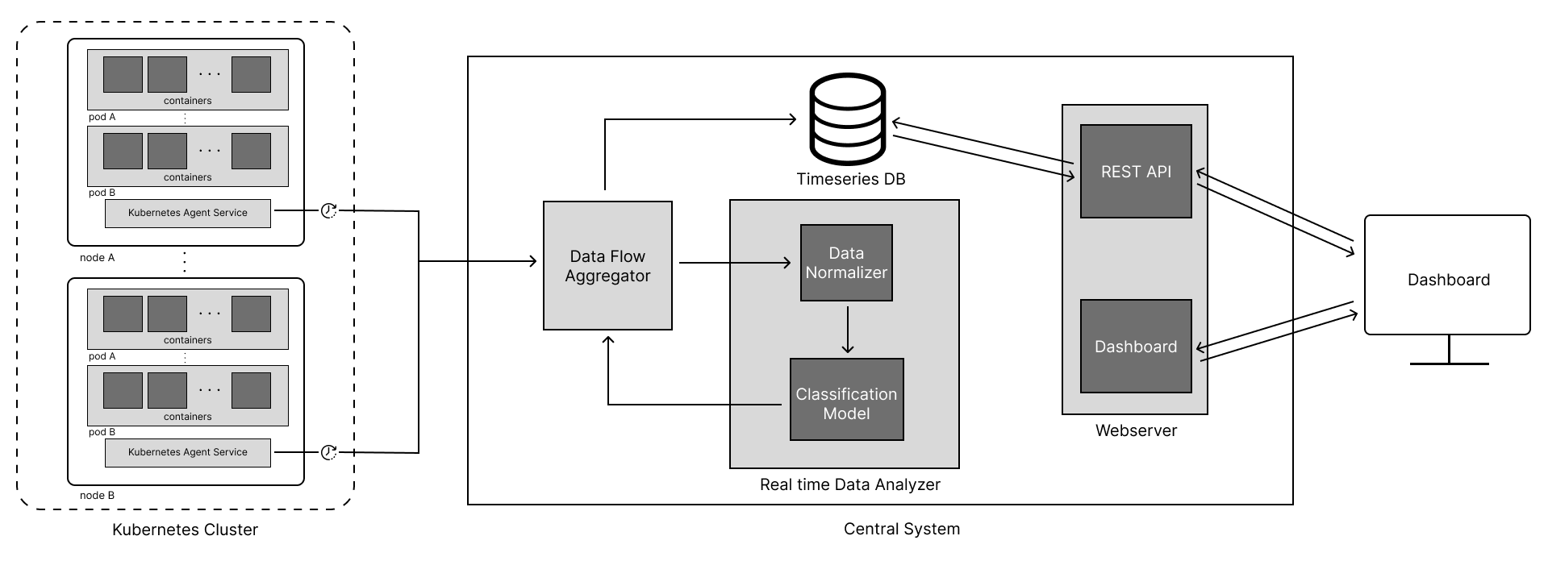
Dashboard Snapshot
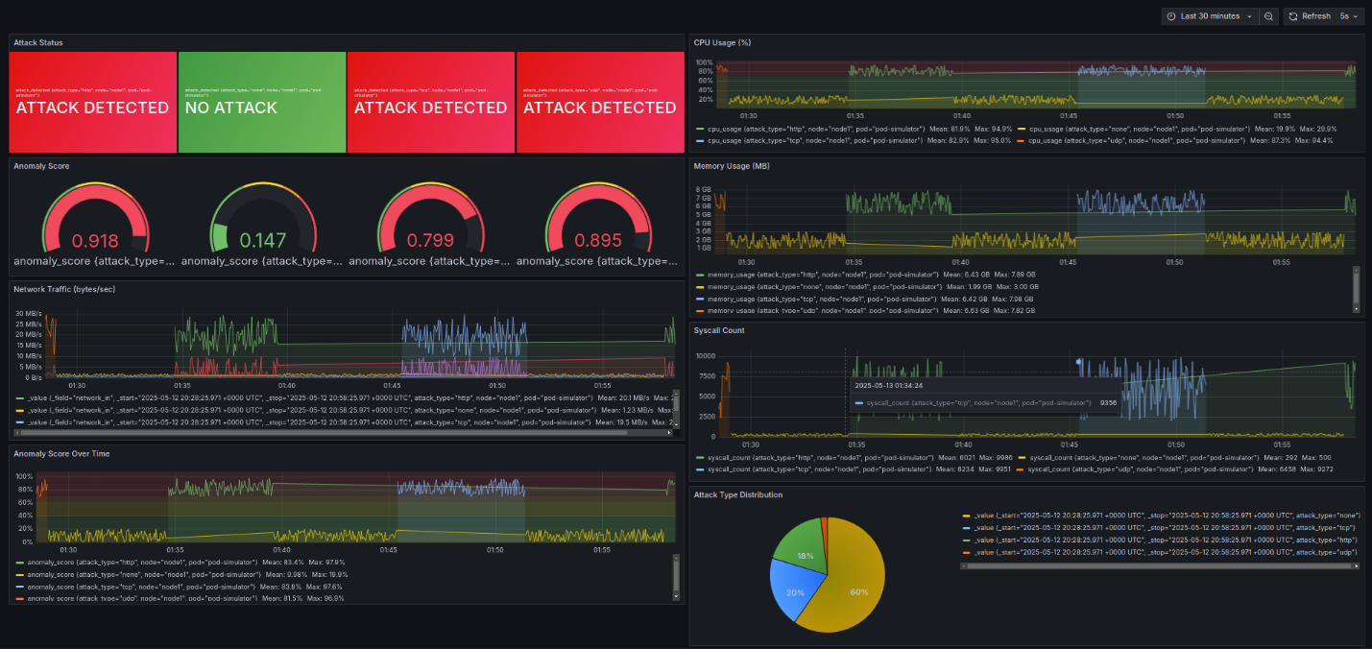
4. Results and Discussion
4.1 FYP-I Findings
After successfully deploying a four-node Kubernetes cluster and implementing a botnet simulation environment with a Command and Control (CnC) server, we conducted extensive model evaluations using the collected dataset. This dataset consisted of over 55,000 rows of telemetry data, captured at 3-second intervals, and included system calls and resource metrics from all worker nodes during both normal operations and various DDoS attack scenarios (HTTP, UDP, TCP, and ICMP floods). Preliminary data analysis revealed that although Kubernetes effectively mitigated much of the attack traffic, distinct patterns persisted in system call and resource utilization data.
We implemented and evaluated four machine learning models using a 90-10 train-test split, validating their performance through 5-fold cross-validation. The Random Forest Classifier, configured with 100 estimators, delivered exceptional performance with 99.8% accuracy, precision, recall, and F1 score. It trained in approximately 1.01 seconds and tested in 0.04 seconds, making it highly efficient for real-time detection scenarios. Feature importance analysis highlighted that network-related system calls such as accept, connect, and sendto, alongside certain network metric features, were key to identifying attack signatures.
The Decision Tree Classifier also performed strongly, achieving 95.4% accuracy, with similar precision, recall, and F1 scores, while requiring minimal computation time (0.07 seconds for training and 0.002 seconds for testing).
In contrast, non-tree-based models struggled with the classification task. The Support Vector Machine (SVM) with a linear kernel achieved only 48.6% accuracy, and Logistic Regression performed even worse at 43.0%. Both models had poor performance across all evaluation metrics and longer training times, with SVM taking 3.32 seconds to train. Confusion matrix analysis reinforced these results, showing that while tree-based models effectively distinguished between attack types, SVM and Logistic Regression frequently misclassified them.
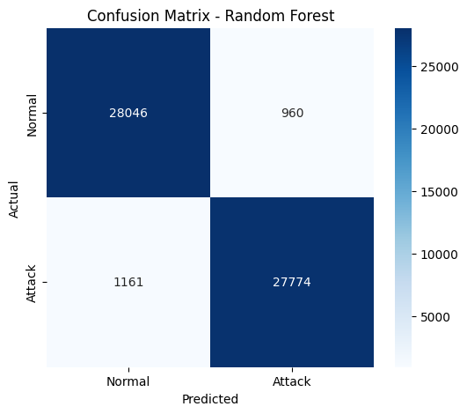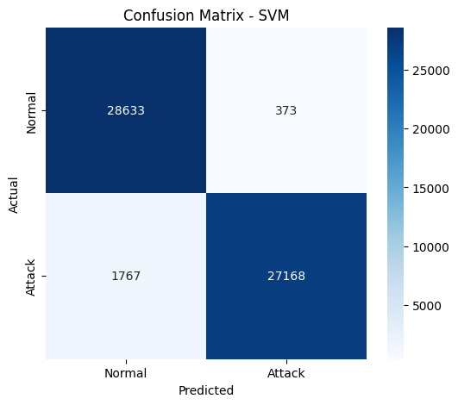
This significant performance gap indicated that the relationship between the telemetry metrics and attack classes was highly non-linear, favoring the hierarchical decision-making capabilities of tree-based models. However, the high accuracy of the Random Forest model raised concerns about potential overfitting, despite cross-validation being used.
These insights informed our decision to explore more robust models in FYP-II. Nevertheless, FYP-I successfully demonstrated that even with Kubernetes’ built-in mitigation absorbing much of the attack impact, detectable patterns remained in the telemetry data. These results validated our data collection approach and agent architecture while highlighting the effectiveness of tree-based models for detecting DDoS attacks in Kubernetes environments.
4.2 FYP-II Findings
In FYP-II, we redesigned the system architecture by removing MetalLB’s load balancing abstraction and deploying a custom CPU-intensive HTTP server, which significantly improved the differentiation between normal and attack traffic. The refined telemetry pipeline generated a new dataset that served as the foundation for training and evaluating deep learning models, particularly designed to capture the temporal patterns of DDoS attacks in Kubernetes.
We began with thorough preprocessing, as documented in the FYP_Final.ipynb notebook. Four low-variance features (node_sockstat_TCP_inuse, node_sockstat_UDP_inuse, node_network_receive_errs_total, and node_netstat_Tcp_CurrEstab) were removed, and the remaining features were normalized using StandardScaler. We restructured the data into time-series sequences suitable for Recurrent Neural Networks (RNNs), and encoded the target variable by mapping attack types to numerical values. To reduce noise, we segmented the dataset by attack type (HTTP, TCP, UDP), allowing each model to focus on a single protocol.
We implemented two deep learning models: Long Short-Term Memory (LSTM) and Gated Recurrent Units (GRU). Both used similar architectures, consisting of a 64-unit recurrent layer, a 0.2 dropout layer for regularization, a dense ReLU layer, a second dropout layer, and a softmax output layer for classification. We trained the models using categorical crossentropy loss and the Adam optimizer, testing performance across 20, 50, and 100 epochs.
The LSTM model performed consistently well, achieving:
- 92% accuracy at 20 epochs,
- 94% at 50 epochs,
- and 95% at 100 epochs.
After feature refinement, performance improved further to:
- 94%, 95%, and 96%, respectively.
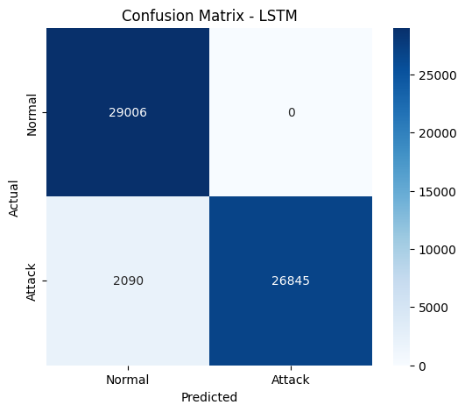
The GRU model followed a similar trajectory:
- Starting with 91% accuracy at 20 epochs,
- Reaching 95% at 100 epochs.
- Post-feature refinement, it improved to 94% at 20 epochs and maintained 95% at 100 epochs.
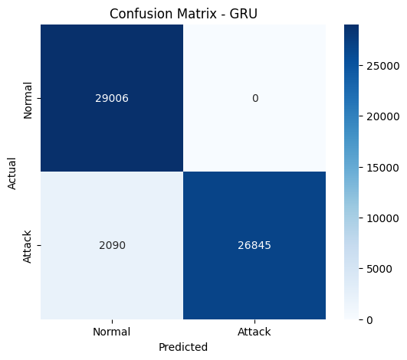
Both models demonstrated smooth learning curves and consistent reductions in loss, indicating stable and reliable learning. Confusion matrix analysis confirmed that both architectures were highly effective in distinguishing between normal and attack traffic, with minimal misclassifications.
Although the deep learning models did not surpass the Random Forest’s 99% accuracy from FYP-I, they proved highly effective at capturing the temporal characteristics of DDoS behavior. While LSTM slightly outperformed GRU with a peak accuracy of 96%, the GRU's simpler architecture achieved nearly the same performance, suggesting that LSTM's additional complexity offered only marginal benefits for this task.
This run’s results validated our strategy of removing Kubernetes' protective abstractions and designing CPU-intensive workloads to generate clearer attack signatures. The deep learning models successfully detected these patterns in the enhanced dataset, showcasing the viability of recurrent architectures for real-time DDoS detection in Kubernetes. Taken together with FYP-I, our findings suggest that a hybrid detection system combining tree-based models for precision and deep learning models for temporal analysis would provide a robust solution for mitigating DDoS threats in modern containerized environments.
5. Conclusion
In this research, we dug into how machine learning (ML) and deep learning (DL) models can help detect DDoS attacks in a Kubernetes environment. In FYP-I, we saw just how powerful tree-based models can be, especially Random Forest, which nailed 99.8% accuracy. Even though Kubernetes' built-in protections did a good job absorbing some of the attack traffic, we still found clear attack patterns in the system calls and resource usage. On the flip side, models like Support Vector Machine (SVM) and Logistic Regression didn’t perform as well, showing us just how non-linear the relationship is between telemetry data and attack types.
FYP-II brought a fresh twist, where we took away Kubernetes’ protective features and threw in a CPU-intensive server to generate clearer attack signals. This time, we turned to deep learning models—LSTM and GRU. While LSTM came out slightly ahead with 96% accuracy, GRU wasn’t far behind with 95%. Both did a fantastic job of capturing the timing and sequence of DDoS behavior.
When we put everything together, we found that a hybrid system—mixing tree-based models for accuracy and deep learning models for detecting attack patterns over time—would probably be the best approach for real-time DDoS detection in containerized environments like Kubernetes. These findings really show the potential of these models for improving security in cloud-native setups and provide a solid foundation for future research.
Looking ahead, there’s room for even more improvements. We could explore combining both ML and DL models into an ensemble system to get the best of both worlds. It would also be interesting to test these models with more diverse attack scenarios and larger datasets to see how well they scale. And of course, diving into more advanced Kubernetes mitigation techniques—like service meshes or smarter load balancing—could be the next step in improving detection accuracy even more.
References
- Anemogiannis, M. (2023). Hierarchical anomaly detection strategy for Kubernetes resources.
- Du, M., et al. (2018). DeepLog: Anomaly Detection and Diagnosis from System Logs through Deep Learning.
- Zou, H., et al. (2019). Docker container anomaly monitoring system based on optimized isolation forest algorithm.
- Tien, C. W., Liao, J. W., Chang, S. C., & Kuo, S. Y. (n.d.). KubAnomaly: Anomaly detection for the Docker orchestration platform with neural network approaches.
- Lin, Y., Tunde-Onadele, O., & Gu, X. (n.d.). CDL: Classified Distributed Learning for Detecting Security Attacks in Containerized App.
- Forsberg, J. (2022). Automatic anomaly detection and root cause analysis for microservice clusters.
- Harlicaj, E. (n.d.). Anomaly Detection of Web-Based Attacks in Microservices.
- Darwesh, G., Hammoud, J., & Vorobeva, A. A. (n.d.). A novel approach to feature collection for anomaly detection in Kubernetes environment and agent for metrics collection from Kubernetes nodes.

